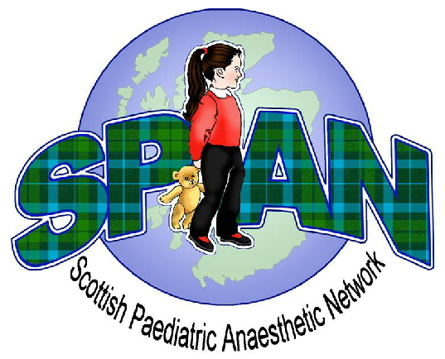
Paediatric Critical Care
SPAN Winter Educational Meeting 2015
Friday 11th December 2015
Teacher Building, Glasgow

Fee: Consultant £100 Trainee £60 Non-Medical FREE

Name…………………………………………………………………………….

Grade……………………………………………………………………………

Hospital…………………………………………………………………………

Contact Address………………………………………………………………

……………………………………………………………………………………

Email Address .........................................................................................

Specific Dietary requirements………………………………………………

If paying by cheque please make payable to ‘SPAN’ & send, with this competed form, to:  Dr Susan McIlveney  Department of Anaesthesia  2nd Floor  Royal Hospital for Children  1345 Govan Road  Glasgow  G51 4TF | If wishing to pay by electronic transfer please  e-mail this completed form to Dr Susan McIlveney and request details of electronic payment  susan.mcilveney@nhs.net

Additional forms and information will be available on both the SPAN website and the SPAN Facebook page. Follow us for the latest updates.
www.span.scot.nhs.uk  www.facebook.com/span.scotland

Any additional enquiries please direct to nealwillis@nhs.net

Receipt for Payment

Applicant Name ………………………………………………………………………………………………………………………………………………………………

Name of Event Paediatric Airway Management

Date of Event 11th December 2015

Fee Paid £60 / £100

Received by ……………………………………………………………………… Date ……………………………………………………………………………

