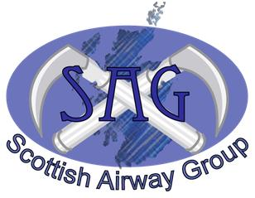
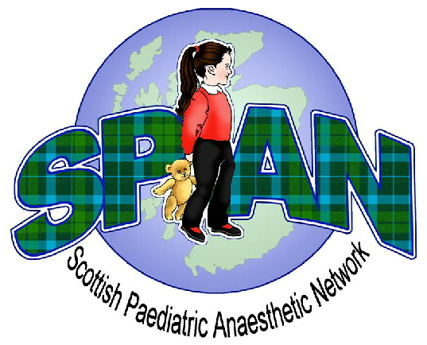
Paediatric Airway Management
Winter Educational Meeting 2014
Friday 28th November 2014
Teacher Building, Glasgow

Fee: Consultant £100
Trainees £60

Name…………………………………………………………………………….

Grade……………………………………………………………………………

Hospital…………………………………………………………………………

Are you a Paediatric/Airway* Lead for your Dept? YES / NO
*delete as applicable
Which society are you affiliated with primarily? SPAN / SAG

Contact Address………………………………………………………………

……………………………………………………………………………………

Email Address .........................................................................................

Specific Dietary requirements………………………………………………

Please make cheques payable to ‘SPAN’ and send with this completed application form to:
Dr Neal Willis (SPAN)
Department of Anaesthesia
Royal Hospital for Sick Children
Dalnair Street
Glasgow G3 8SJ

Preference will be given to paediatric leads and consultants until 31st August 2014
Closing date for applications: Friday 3rd October 2014

Additional forms may be downloaded from the respective SPAN and SAG websites;

www.span.scot.nhs.uk www.scottishairwaygroup.co.uk

Any additional enquiries please direct to nealwillis@nhs.net

Receipt for Payment

Applicant Name ………………………………………………………………………………………………………………………………………………………………

Name of Event Paediatric Airway Management

Date of Event 28th November 2014

Fee Paid £60 / £100

Received by ……………………………………………………………………… Date ……………………………………………………………………………

