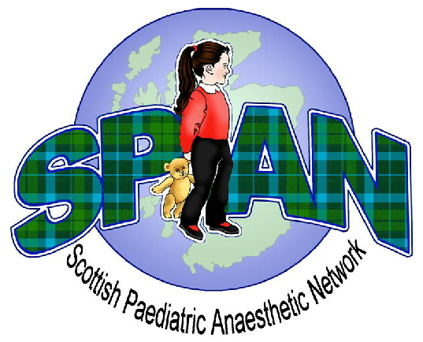
SPAN Spring Meeting 2016

Friday 13th May 2016
Teacher Building, Glasgow

09:00 – 09:25 Registration and Coffee

09:25 – 09:30 Welcome

09:30 – 09:45 APRICOT: An Update Tom Engelhardt
09:45 – 10:45 Neonatal Emergencies Joanne Stirling

10:45 – 11:15 Coffee and Poster Presentations

11:15 – 12:15 Intravenous Fluid Therapy in Children Chris Gildersleve

12:15 – 13:15 Lunch

13:15 – 13:45 Trainee Presentations Chair: Laura Jack
13:45 – 14:30 Annual General Meeting Chair: Chris Hawksworth

14:30 – 15:00 Coffee

15:00 – 16:00 National Morbidity & Mortality Meeting Chair: Chris Hawksworth



