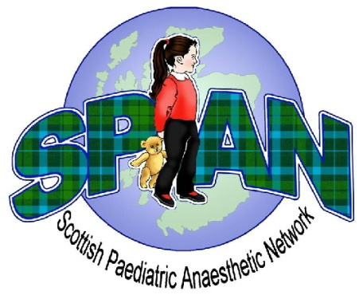
SPAN Spring Meeting 2017

Provisional Programme
Friday 21st April 2017
Crieff Hydro Hotel

09:00 – 09:25 Registration and Coffee

09:25 – 09:30 Welcome

09:30 – 10:15 General Surgery of Childhood: 10 years on from Youngson Atul Sabharwal
10:15 – 10:30 Skill retention in paediatric anaesthesia David Rowney
10:30 – 11:15 Skill retention: The ‘remote & rural’ perspective Dora Paal

11:15 – 11:45 Coffee and Poster Presentations

11:45 – 12:30 Paediatric laparotomy audit in SWACA Simon Courtman

12:30 – 13:30 Lunch

13:30 – 14:00 Trainee Presentations Chair: Laura Jack
14:00 – 14:30 Annual General Meeting Chair: John Rutherford

14:30 – 15:00 Coffee

15:00 – 16:00 Consent in paediatric anaesthesia (Post-Montgomery) Jillian McFadzean
16:00 – 16:15 APRICOT update Tom Engelhardt

Accredition of this meeting for CPD recognition is being applied to the RCoA

