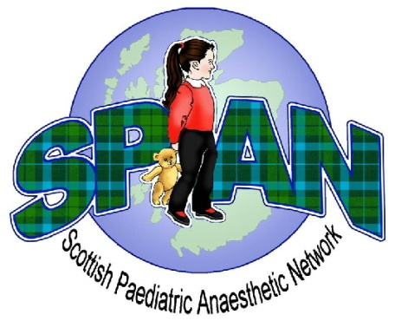
SPAN Spring Meeting 2018

Provisional Programme
Friday 24th April 2018
Royal College of Surgeons, Edinburgh

09:00 – 09:25 Registration and Coffee

09:25 – 09:30 Welcome

09:30 – 10:15 Fasting guidelines for paediatrics, updated APA guidance Sumit Das, Oxford

10:15 – 11:00 Pre-assessment of children for paediatric anaesthesia Suzanne Boyle

11:00 – 11:30 Coffee and Poster Presentations

11:30 – 12:00 Paediatric refresher attachment, the DGH perspective KayAnn Dell
12:00 – 12:30 Paediatric refresher attachment, the tertiary perspective Graham Wilson

12:30 – 13:30 Lunch

13:30 – 14:00 Trainee Presentations Chair: Laura Jack

14:00 – 14:15 Report: Visit to Birmingham Children’s hospital Charlotte Heath

14:15 – 14:45 Annual General Meeting Chair: John Rutherford
14.15 - 14.45 Trainee session Laura Jack

14:45 – 15:15 Coffee

15:15 – 16:15 Who should consent for MRI? The paediatrician, radiologist or anaesthetist? A panel discussion. Kamath Tallur, Susie Goodwin, Colin Young tbc

16:15 – 16:30 APRICOT: the UK data John Rutherford

Accredition of this meeting for CPD recognition is being applied to the RCoA

