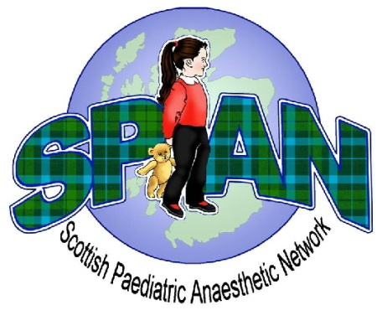
SPAN Spring Meeting 2018

Provisional Programme
Tuesday 24th April 2018
King Khalid Building, Royal College of Surgeons, Edinburgh

09:00 – 09:25 Registration and Coffee

09:25 – 09:30 Welcome

09:30 – 10:15 Fasting guidelines for paediatrics, updated APA guidance
1A01 Dr Sumit Das, Consultant Paediatric Anaesthetist, Oxford

10:15 – 11:00 Pre-assessment of children for paediatric anaesthesia
2A03, 2D07 Dr Suzanne Boyle, Consultant Paediatric Anaesthetist, Edinburgh

11:00 – 11:30 Coffee and Poster Presentations

11:30 – 12:00 Paediatric refresher attachment, the DGH perspective
12:00 – 12:30 Paediatric refresher attachment, the tertiary perspective
2D02 Dr KayAnn Dell, Consultant Anaesthetist, Dunfermaline
Dr Ros Lawson, Consultant Paediatric Anaesthetist, Glasgow

12:30 – 13:30 Lunch

13:30 – 14:00 Trainee Presentations
Chair: Dr Laura Jack, Anaesthetic trainee

14:00 – 14:15 Report: Visit to Birmingham Children’s hospital
Dr Charlotte Heath, Anaesthetic trainee

14:15 – 14:45 Annual General Meeting (Chair: John Rutherford)
14.15 - 14.45 Trainee session Dr Laura Jack

14:45 – 15:15 Coffee

15:15 – 16:15 Who should consent for MRI? The paediatrician, radiologist or anaesthetist? A panel discussion. Dr Kamath Tallur Paediatric neurologist, Dr Stephanie Shearer Paediatric ST,
1F01 And colleagues

16:15 – 16:30 APRICOT: the UK data
1I05 Dr John Rutherford, Consultant Anaesthetist, Dumfries

The RCoA has approved this programme for 5 CPD points.

