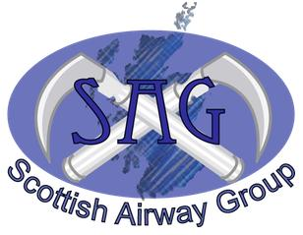
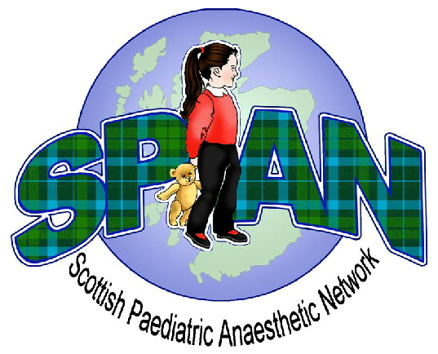
Paediatric Airway Management
Winter Educational Meeting 2014
Friday 28th November 2014
Teacher Building, Glasgow

Consultants/SAS Grades £100
Trainees £60

5 CPD POINTS APPLIED FOR

09:00 – 09:25 Registration and Coffee

09:25 – 09:30 Welcome Neal Willis

Session 1 Chair: Dr Lesley McKee, RHSC Glasgow
09:30 – 09:50 The approach to unanticipated airway difficulty Thomas Engelhardt
09:50 – 10:10 Pitfalls of paediatric airway management Dave Ball
10:10 – 10:30 Organisational aspects of airway equipment Neal Willis
10:30 – 10:50 Panel Discussion

10:50 – 11:20 Coffee and Trade Exhibition

Session 2 Chair: Dr Alistair McNarry, Edinburgh
11:20 – 11:50 Help! I’ve never heard of this syndrome… Corina Lee

11:50 – 12:40 Debate: Front of neck access in children should only be attempted by surgeons
CHAIR: Dr Alistair McNarry, Edinburgh
FOR: Mr Haytham Kubba, RHSC Glasgow
AGAINST: Dr Alyson Walker, RHSC Glasgow

12:40 – 13:30 Lunch and Trade Exhibition

Session 3: Workshops
13:30 – 14:05 Workshop 1: Supraglottic Airway Device and Fibreoptic Intubation
14:05 – 14:40 Workshop 2: Interactive Case Discussion: Management of the Critical Airway

14:40 – 15:10 Coffee and Trade Exhibition

15:10 – 15:45 Workshop 3: Video Laryngoscopy
15:45 – 16:20 Workshop 4: Cricothyroidotomy
16:20 – 16:55 Workshop 5: Rigid Bronchoscopy for Airway Rescue

16:55 Close

