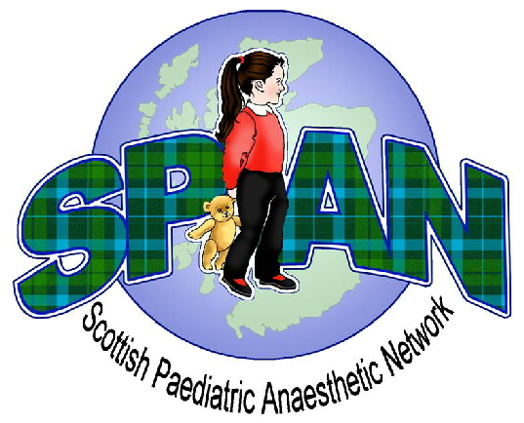
SPAN Spring Meeting 2017
Friday 21st April 2017
Crieff Hydro Hotel, Perthshire

Fee: Consultant £100 Trainee £50 Non-Medical Staff FREE!

Name…………………………………………………………………………….

Grade……………………………………………………………………………

Hospital…………………………………………………………………………

Contact Address………………………………………………………………

……………………………………………………………………………………

……………………………………………………………………………………

Email Address .........................................................................................

Specific Dietary Requirements………………………………………………

If you are wishing to book a place for non-medical staff, please fill out this application form and e-mail it to craigcumming@nhs.net but do not send any payment.
Remember, if you are not medical staff then SPAN will reimburse your travel costs on production of the appropriate receipts.

If paying by cheque please make payable to ‘SPAN’ & send, with this competed form, to:  Dr Craig Cumming  Dept of Anaesthesia  6th Floor  Ninewells Hospital and Medical School  Dundee  DD1 9SY | If wishing to pay by electronic transfer please  e-mail this completed form to craigcumming@nhs.net  And pay the appropriate amount of money to this account, using your full name as the payment reference:  Account Name: Scottish Paediatric Anaesthetic Network  Account Number: 60517381  Sort Code: 82 70 13

Additional forms and information will be available on the SPAN website. Follow us for the latest updates.
www.span.scot.nhs.uk  www.facebook.com/span.scotland

Any additional enquiries please contact us at span.webmaster@gmail.com

