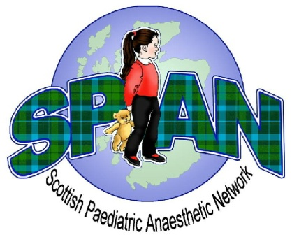
SPAN Spring Meeting 2018

Tuesday 24th of April.
King Khalid Builiding,
Royal College of Surgeons in Edinburgh.

Name…………………………………………………………………………….

Grade……………………………………………………………………………

Hospital…………………………………………………………………………

Contact Address………………………………………………………………

……………………………………………………………………………………

……………………………………………………………………………………

Email Address ...............................................................................

Specific Dietary Requirements………………………………………......

Fees: Consultant £100 Trainee £50 Non-Medical Staff FREE!

Please pay by internet banking to the account of SPAN to book your place:

Account Name: Scottish Paediatric Anaesthetic Network
Account Number: 60517381
Sort Code: 82 70 13

Reference: YOUR NAME

If you are wishing to book a place for non-medical staff, please fill out this application form and e-mail it to craigcumming@nhs.net but do not send any payment.

If you are other than medical staff then SPAN will reimburse your travel costs on production of the appropriate receipts.

Additional forms and information will be available on the SPAN website. Follow us for the latest updates.
www.span.scot.nhs.uk www.facebook.com/span.scotland

