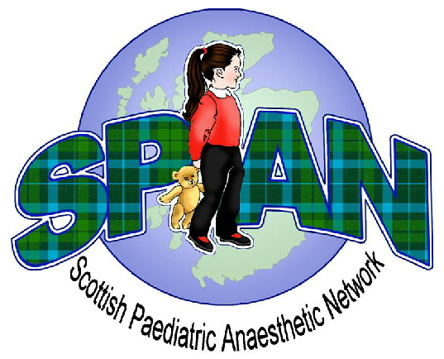
Scottish Paediatric Anaesthetic Network
8th Annual Spring Meeting and AGM
Friday 25th April 2014
Dunblane Hydro Hotel by Doubletree Hilton

Programme

0930 - 1000 Coffee & Registration

1000 - 1030 Codeine – the way forward in paediatric practice
Dr Mike Tremlett (Matrix codes: 2D05,1A02)
Consultant Anaesthetist, South Tees Hospitals

1030 - 1045 Questions

1045 - 1115 Coffee

1115 – 1145 Can’t Intubate, Can’t Ventilate in Paediatrics Dr Alyson Walker ( 1B02, 2A01,3A01)
Consultant Anaesthetist, RHSC Glasgow

1145 - 1200 Questions

1200 - 1300 Audit & Research Presentations

1300 - 1400 LUNCH

1400 - 1440 SPAN AGM
Update on the APRICOT Study (3J00)
Dr Thomas Engelhardt,
Aberdeen Royal Infirmary

1440 - 1530 “A National Morbidity & Mortality Meeting”
A selection of paediatric cases from a variety of centres.
Short case presentations followed by group discussion.
(1I01, 1I02, 2A02, 2D07)

- Close of Meeting

Booking forms are available to download from the SPAN website:
www.span.scot.nhs.uk

Remote and Rural Colleagues – for access to meeting via video - link contact Dr Lesley McKee (lesley.mckee@nhs.net)

This meeting has approval from the Royal College of Anaesthetists for 5 CPD points

