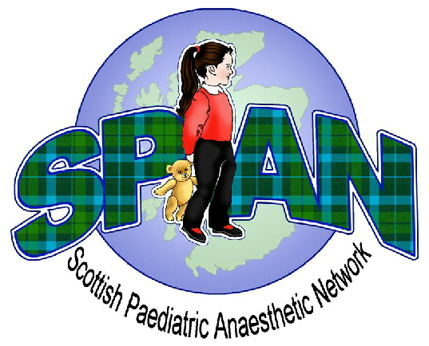
SPAN Winter Educational Meeting 2015
Paediatric Critical Care

Friday 11th December 2015
Teacher Building, Glasgow

09:00 – 09:25 Registration and Coffee

09:25 – 09:30 Welcome

Session 1
09:30 – 09:50 The Sick Baby
09:50 – 10:10 Paediatric Retrieval. What to do and what to expect
10:10 – 10:30 Anaesthetising the Critically Ill Child
10:30 – 10:40 Panel Discussion

10:40 – 11:10 Coffee / Poster Presentations

Session 2
11:10 – 11:30 Management of Head Injury in Children
11:30 – 11:50 The child with complex needs / CYPADM presenting to ED
11:50 – 12:10 Poisoning in Children
12:10 – 12:20 Panel Discussion

12:20 – 13:15 Lunch / Poster Presentations

Session 3
13:15 – 13:45 Oral Presentations (strictly 10 minutes each)

Session 4 Afternoon Workshops
13:45 14:25 Head Injury. Interactive Case Discussion
14:25 15:05 Sepsis

15:05 - 15:30 Coffee / Prizes for Oral and Poster Presentations

15:30 – 16:10 Neonatal
16:10 – 16:50 Trauma
16:50 – 16:55 Meeting Close

