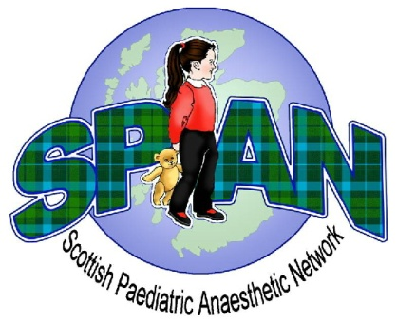
SPAN grant funding for projects.

Application form.

Name of project:
Scottish Paediatric Tracheostomy Initiative

Name(s) of applicant(s) |  | Place of work:
Principal applicant:
Name:

Postal address:

e-mail:

Telephone number

The SPAN committee is asked to consider:

The Scottish Paediatric Tracheostomy Initiative (SPTI) is aiming to achieve consistent, high quality care for all children in Scotland with a tracheostomy. This is being supported by many Scottish hospitals and we have signed up to be part of this initiative. The main objective is the delivery of emergency tracheostomy training to all frontline staff in Scotland who may encounter a child with a tracheostomy. To facilitate this we are looking for financial backing to purchase an inexpensive doll’s head which can be easily modified to suit the purpose of low fidelity simulation to assist delivering high quality training without resorting to expensive mannequins.

Signature of the principal applicant: ……………. Date of submission:……………………

Project details:

Executive summary

Project aims / objectives
The SPTI is aiming to standardise emergency tracheostomy care for all children in Scotland by delivering consistent training to all frontline staff who may encounter children with a tracheostomy.

Background
SPAN is supporting this initiative as a way of bringing tracheostomy care in line with adult practice and standardise emergency care. This is in keeping with recommendations from NAP4 and is being supported using resources freely available from the NTSP website.

Methodology / project plan
Over the next 6 months, Scottish hospitals will be using NTSP resources and a “Trachy Tracey” mannequin to deliver low fidelity simulation through small group teaching to ensure full delivery of training to all relevant staff. This includes intensive care, emergency departments and theatres. Success of the project aims will be measured 6 months after implementation with a survey looking at provision of training and geographic coverage of the initiative

Resources requested from SPAN
We would like to request funds to cover the purchase of a “Girl’s World” doll at a price of (insert current price on Amazon here)

Details of other agencies approached for support

Notes for applicants:

- At least one applicant must be working at NHS in Scotland.

- The project group must be able to demonstrate relevant experience /expertise. The principal applicant should submit a short personal supporting statement and curriculum vitae.

- The project must be relevant for the specialty of paediatric anaesthesia.

- Applications should be submitted to the SPAN Secretary. The committee will review the application and will notify applicants of the outcome within four weeks.

- Applications can be submitted at any time during the year.

- Each application will be considered on its merits, taking into account the SPAN’s current financial position. If the number of applications exceeds the capacity of SPAN’s support, projects with the aims/benefits applicable across the paediatric services in Scotland will be given a priority.

- The project must be started within one year of the award or the funds will need to be returned. The timetable for the project will be agreed between the applicant(s) and SPAN as a condition of any award.

- Applicants must submit a report to the SPAN secretary and a final report for the SPAN website and Annual General Meeting at the conclusion of the project.

