

**Capnography Education**

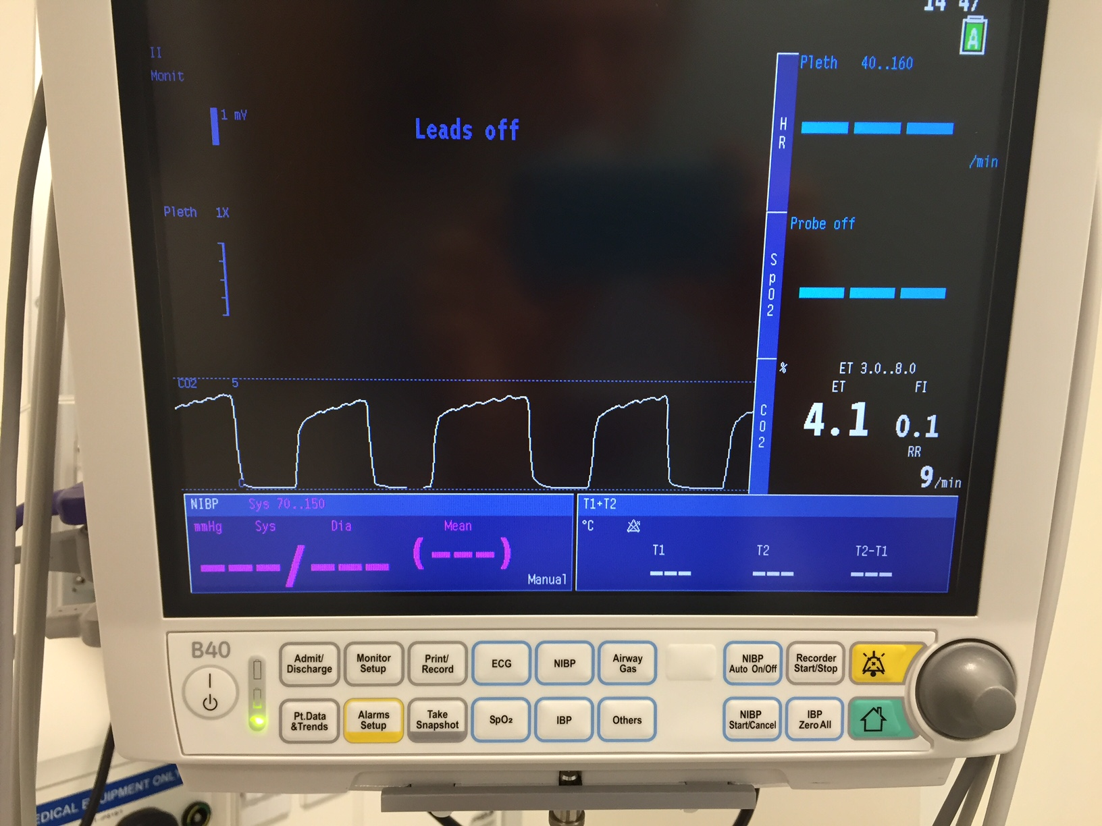

**Introduction**

This workbook is intended as an introduction to the use of capnography as a monitoring tool.

Capnography helps identify situations that can lead to hypoxia, which could lead to irreversible brain damage and/or death.

Recent reports and guidelines have emphasised the importance of capnography and highlighted that failure to use or correctly interpret capnography contributed to adverse events, including death.

Education in the use of capnography is therefore essential in reducing morbidity and mortality.

Please email [nealwillis@nhs.net](mailto:nealwillis@nhs.net) once you have completed this workbook to be sent an assessment. 100% will be required in this short assessment for successful completion of the learning package. A certificate will be issued on successful completion of the assessment.

**Aims and Learning Objectives**

**Aims**

To provide an understanding / consolidate existing knowledge on the use of capnography

**Learning Objectives**

1. Consolidate understanding of CO2 related physiology
2. Establish what national guidelines exist for the use of capnography outside the operating theatre and explain why these are in place
3. Improve confidence in interpretation of capnography
4. Emphasise the significance of a flat capnograph trace
5. To be able to recognize an abnormal capnograph trace and to act in an appropriate way to keep your patient safe
6. Demonstrate understanding of the above by completing a small quiz

**Objective 1: Consolidate understanding of CO2 physiology**

Where does CO2 come from and how does it get to be exhaled?

Figure : The journey of CO2 from cells to exhalation

So, regarding CO2, we can see that;

* + Carbon Dioxide is exhaled with every breath and should therefore be present and detectable in every exhalation
  + If no CO2 is being breathed out then either there is no CO2 travelling to the lungs to be breathed out or the airway is completely obstructed and the CO2 being produced cannot leave the body

CO2 and Cardiac Output

We have just seen that CO2 is produced in the cells during metabolism, and that in order for us to breathe out CO2 the blood carrying it has to travel through the heart and into the pulmonary circulation.

**Exercise 1:** Imagine that cardiac output has reduced, or even stopped (so less blood is being pumped by the heart for some reason). Will the amount of CO2 exhaled remain the same? Take a few moments to imagine this happening with one of your patients and then check the answer. **The answer can be found at the end of the workbook.**

By understanding the process of CO2 production and its journey to exhalation, the physiological factors that determine what is seen on the capnograph trace can be better understood.

Figure : All of these factors must be considered when interpreting CO2 and capnograph

**Objective 2 : National Guidelines**

**National Guidelines for use of Capnography**

The Association of Anaesthetists of Great Britain and Ireland (AAGBI) published updated guidelines in December 2015 entitled “Recommendations for standards of monitoring during anaesthesia and recovery”.

These state that;

* “Departments should work towards providing full monitoring, including capnography, in patients with a tracheal tube or supraglottic airway in situ… in the recovery area”.
* “In summary, the minimum monitoring for recovery from anaesthesia includes… capnography if the patient has a tracheal tube, supraglottic airway device in situ or is deeply sedated”.



**Evidence to prove the use of capnography can make a difference**



* Joint project involving the Difficult Airway Society and the Royal College of Anaesthetists. Published in **May 2011**
* UK wide prospective study to determine incidence of major airway complications
* Data was requested from all UK centres for all patients undergoing airway management. All submitted cases were reviewed and considered for inclusion

The scope of the problem

* 133 reports related to anaesthesia during NAP 4 data collection
* **16 occurred in theatre recovery, including 2 deaths**
* In ALL reported cases, AIRWAY OBSTRUCTION was the root cause of the problem
* In 50% of cases there was a delay in recognising the problem
* Hypoxia caused cardiac arrest in 5 patients
* 1 sustained brain damage
* Most were admitted to ICU

The following is a case report which was submitted to NAP 4:

* A young, healthy adult patient with normal body habitus and normal airway examination underwent plating of facial fractures
* Extubation was uneventful but subsequent airway obstruction went unrecognised in recovery until the patient became hypoxic
* Although the airway obstruction was then recognised and corrected, the oxygen saturation of 80% failed to improve and pulmonary oedema was apparent
* The patient needed re-intubated and was admitted to intensive care for ventilation
* The pulmonary oedema had been caused by the patient attempting to breathe whilst the airway was obstructed. This causes fluid to be drawn into the lung tissue under negative pressure
* It is clear to see that, in this case, the use of capnography would have allowed the airway obstruction to be identified more quickly, possibly before desaturation, and if acted upon appropriately the patient would have been less likely to have developed pulmonary oedema

**Objective 3 and 4: Capnography Interpretation and significance of flat capnography trace**

What information does capnography provide?

* CO2 value (units are kPa). The value we quote and document in this context is the ETCO2 (End Tidal CO2). This is the value of CO2 at the very end of breathing out, and is what the bedside monitors will use as a value.
* CO2 waveform. The shape of the capnograph is arguably more important than the absolute ETCO2 value and is described below;

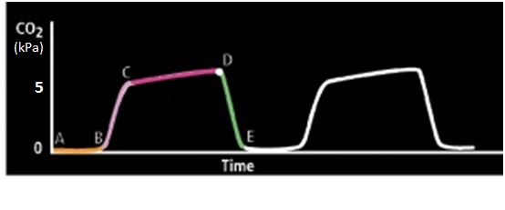

Figure : A normal capnography waveform

|  |  |  |  |
| --- | --- | --- | --- |
| **Part of Trace** | **Name** | **What is happening?** | **Relevance for Interpretation** |
| **A-B** | Inspiratory  baseline | Patient has finished breathing in and is about to breathe out | This line should be at a value of zero. If the trace does not return to zero, the flow of oxygen is inadequate in the circuit and needs increased until this part is at zero |
| **B-C** | Expiratory upstroke | Patient is starting to breathe out | Initially CO2 will rise quickly if airway is unobstructed. If this line does not rise steeply then there is an obstruction to the patient breathing out (and probably an obstruction to the patient breathing in) |
| **C-D** | Alveolar plateau | This is the latter stages of expiration | Point ‘D’ on the trace is the end tidal CO2 value, as this is the end of expiration of a full tidal volume. This should be relatively flat. If not then there is an obstruction to breathing out, such as obstruction or bronchospasm (as in asthma) |
| **D-E** | Inspiration | The patient is breathing in | Expiration is complete and as the patient breathes in the CO2 trace should fall as sharply as it rose in the expiratory upstroke. If the trace does not fall steeply, there is airway obstruction |

General points in interpretation

1. The capnograph is just one monitor and must be used in conjunction with clinical assessment and other monitors.
2. You need to look at different components of the capnograph to correctly interpret it.
3. There are often several possible explanations for a particular capnograph trace.
4. If there is airway obstruction then the measured value of ETCO2 will not accurately reflect the blood CO2 levels. This may make interpretation of the capnograph unreliable. Ensure the airway is clear and unobstructed to be able to more accurately measure the value of ETCO2.
5. The most important objective in interpreting the capnograph trace is to quickly recognize an abnormal trace, determine what action is immediately needed and to get help as soon as appropriate.
6. Remember that the waveform and value of CO2 will change significantly before the SpO2 in the case of airway obstruction, and is a vital early warning sign.

**Exercise 2:** Imagine you hold your breath for as long as you can (this simulates complete airway obstruction). Which monitor will change first: ETCO2 or oxygen saturation? Take a few moments to imagine this happening with one of your patients and then check the answer. **The answer can be found at the end of the workbook.**

Capnography Interpretation

The following is a suggested approach to interpretation of capnography. Always remember that interpretation of any monitor requires clinical assessment of the patient as well.

Suggested “SAFE” Approach

1. S - Can you **S**ee a CO2 trace?
2. A - What is the **A**ppearance of the waveform?
3. F – What is the **F**requency of the waveform?
4. E – What is the **E**TCO2 value?
5. Can you See CO2?

Figure . Flowchart for capnograph interpretation

**The significance of a flat capnography trace is crucial.** The patient could be in cardiac arrest and/or their lungs are not being ventilated due to either complete airway obstruction or oesophageal intubation. These situations may already be apparent but there are clear case reports in NAP4 highlighting the fact that this is not always the case and had capnography been used, there would have been earlier recognition of airway obstruction which could have prevented or lessened adverse outcomes. In practice an equipment issue could explain a flat trace but the above physiological causes must clearly be excluded.

1. What is the Appearance of the waveform?

Adapted from: “Hats and Caps Capnography Training on Intensive Care”

* + **Anaesthesia** [Volume 68, Issue 4,](http://onlinelibrary.wiley.com/doi/10.1111/anae.2013.68.issue-4/issuetoc) pages 421-421, 11 MAR 2013 DOI: 10.1111/anae.12173/T.M.Cook et al/ [http://onlinelibrary.wiley.com/doi/10.1111/anae.12173/full#anae12173-fig-0001](http://onlinelibrary.wiley.com/doi/10.1111/anae.12173/full)

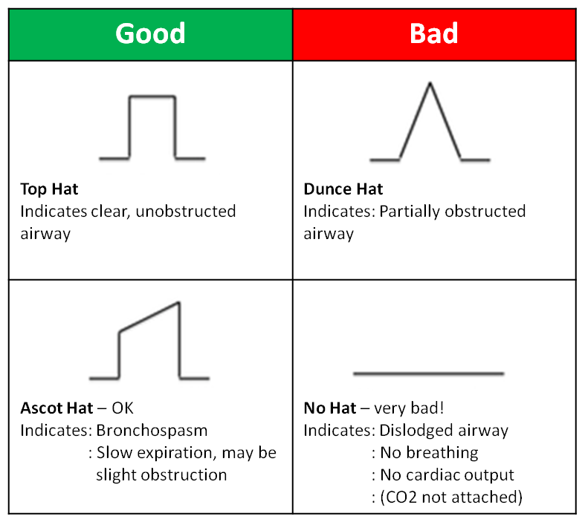

Table 1. Interpretation of the shape of the capnograph trace

**Top Hat:** The steep angles on the ‘sides of the hat’ indicate that airflow in both inspiration and expiration is unobstructed. This trace is reassuring.

**Ascot Hat:** During expiration there is a slight obstruction to air flow. This may be due to a poorly-sitting airway device or bronchospasm. The airway should be checked straight away and optimised.

**Dunce Hat:** There is nowhere on this trace where the airflow (sides of the hat) is seen to be unobstructed. The upstroke and downstroke are at a significant angle so there is obstruction. The airway should be checked and optimised straight away.

**No Hat:** Treat as medical emergency. Check airway, breathing and circulation immediately. If any concerns about the patient then call for help and/or pull the emergency buzzer. *(Check capnograph is attached)* **This further emphasises the potentially critical situation of a flat CO2 trace.**

1. What is the Frequency of the waveform?

Basically is it fast/slow or about right? The frequency of the waveform should reflect the frequency of expiration and therefore respiratory rate (notable exceptions include complete airway obstruction and cardiac arrest- see later).

Once you know this, thinking about what physiological factors might determine respiratory rate becomes much more straightforward, for example:

Is the patient breathing fast? If so, what increases respiratory rate?

* + Cardiovascular or respiratory distress
  + Pain
  + Increased metabolism e.g. pyrexia/ malignant hyperthermia (MH)

Is the patient breathing slow? If so, what decreases respiratory rate?

* + Hypoventilation
    - Ongoing central sedation(e.g. opiates)
    - Inadequate reversal of muscle relaxation
    - Hypothermia

In reality it will be apparent to you from clinical observations including respiratory rate that one of the above issues may be occurring. As mentioned earlier, capnography is one of many monitors, including clinical observation, to be used in conjunction with each other.

1. What is the ET CO2 Value? Normal range 4.0-6.0 kPa

In reality, CO2 values in recovery will often be outwith these values. Most often the values will be altered by pain (lower CO2) or opiate use in theatre (higher CO2). CO2 values must always be interpreted alongside clinical examination and by looking at the shape of the capnograph trace.

**Increased ETCO2 measurement**

|  |  |
| --- | --- |
| **Patient Factors** | **Equipment Factors** |
| Reduced minute ventilation: Could be central depression or due to partial obstruction  (Check hat appearance) | Oxygen flow setting too low: will probably have elevated baseline as CO2 not returning to zero |
| Hypermetabolic  e.g. MH |
| Pyrexia |

Table 2

**Decreased ETCO2 measurement**

|  |  |
| --- | --- |
| **Physiological** | **Equipment** |
| Increased minute ventilation (Increased respiratory rate. See previous section on frequency) | Circuit leak |
| Hypothermia | Partial Obstruction |
| Decreased Cardiac Output |  |

Table 3

Summary of suggested “SAFE” Approach

1. S Can you See a CO2 trace?
2. A What is the Appearance of the waveform?
3. F What is the Frequency of the waveform?
4. E What is the ETCO2 value?

Examples

The following pages include 5 examples of capnography with explanations of reasons for the capnography trace using the SAFE approach. Please feel free to use your own methods of interpretation.

**Example 1**

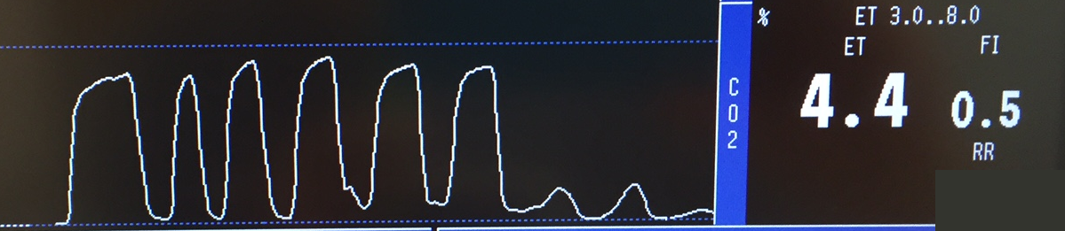

Can you See CO2?

YES, but disappearing and becomes NO.

*Cannot continue to evaluate trace*

This is BAD! Immediate action needed to remedy. Call for help.

Possible causes;

* Oesophageal intubation/ Displaced ETT or LMA
* Airway becoming completely obstructed
* Fall in cardiac output or cardiac arrest

Example 2

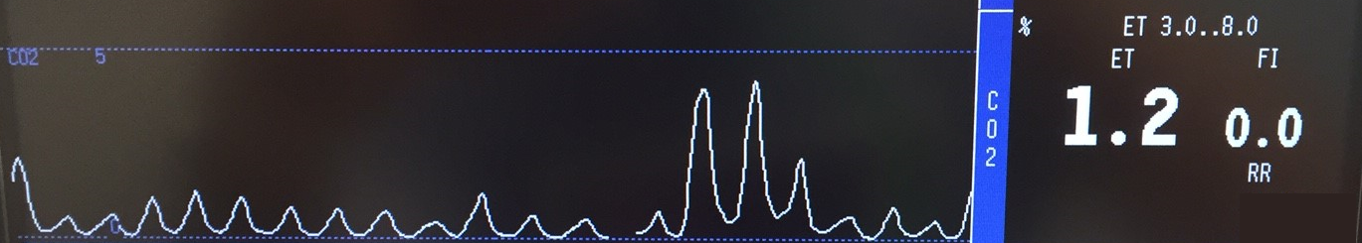

Can you See CO2 – Yes.

*Continue evaluation of trace*

Appearance – Dunce Hat. This is likely to be an obstructed airway

Frequency – Variable, not normal

ETCO2 value – Reduced

Answer – Airway obstruction which requires immediate action. There are likely to be clinical signs of airway obstruction such as;

* + - * Stridor
      * Costal recession
      * Tracheal tug
      * See-saw movement of chest/abdomen

Possible Causes;

* Laryngospasm
* Dislodged airway device
* Other cause for airway obstruction

This patient needs clinically evaluated. Airway, breathing and circulation should be checked and optimised as able. Call for help early if there are any concerns.



Can you See CO2 – Yes

*Continue evaluation of trace*

Appearance – Top Hat. This makes airway obstruction an unlikely cause

Frequency – Constant

ETCO2 – Increasing

Answer – This is a non-obstructed airway but the ETCO2 is rising instead of remaining constant. There are several possible explanations for this picture, which highlights why capnography **must** be used in conjunction with other monitors and clinical examination.

Explanations generally fall into one of two categories,

* inadequate clearance of CO2 from the body (for physiological or equipment reasons)
* increased production of CO2
  + See table 2 on page 13 for more detail

**The main point is to recognise this is not a normal trace and seek help.**

**Example 4**

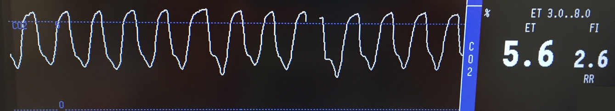

Can you See CO2 – Yes.

*Continue evaluation of trace*

Appearance – Top Hat. This makes airway obstruction an unlikely cause

Frequency – Constant

ETCO2 – Normal ETCO2 value but not baseline not returning to zero

Answer – the gas flow through the breathing circuit is not high enough to flush all the CO2 out of the reservoir before the next breath. The gas flow should be increased until the baseline of the capnograph reaches zero between breaths.

Example 5

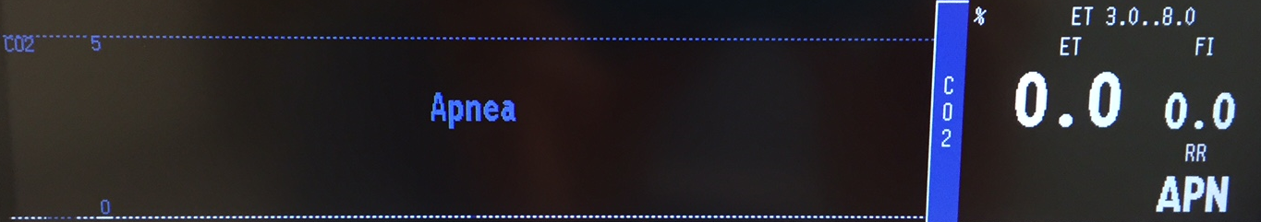

Can you See CO2 – NO (no hat)

*Cannot continue to evaluate trace*

This is BAD! Immediate action needed to remedy. Call for help.

Possible causes;

* Oesophageal intubation/ displaced airway device
* Complete airway obstruction
* Cardiac arrest
* *(Capnograph may not have been connected)*

This patient must be clinically assessed immediately, checking airway, breathing and circulation. If there are any concerns whatsoever then help **must** be sought. This capnograph trace is consistent with cardiac arrest.

**Objectives Recap**

We have reached the end of the workbook and we have covered the following learning objectives;

1. Consolidate understanding of CO2 related physiology
2. Establish what the national guidelines are for capnography use out of theatre and explain why these guidelines are in place
3. Improve confidence in interpretation of capnography
4. Emphasise significance of flat capnograph trace
5. Be able to recognize an abnormal capnograph trace and to act in an appropriate way to keep your patient safe

As mentioned at the start of the workbook there is a short assessment which needs to be passed for successful completion of the module (and to get your certificate). Please e-mail [nealwillis@nhs.net](mailto:nealwillis@nhs.net) to be sent your quiz which will include instructions on how to proceed and submit your answers.

Contributors

This document has been adapted for use by NHS GG&C from an original document written for NHS Tayside by the following people. It has been adapted with their permission.

Katie Harper Specialty Registrar, Anaesthesia, Tayside

Charlotte Targett Specialty Registrar, Anaesthesia, Tayside

Lawrence Li *(Group Lead)* Specialty Registrar, Anaesthesia, Tayside

Barry McGuire Consultant, Anaesthesia, Tayside

Claire Wallace Consultant, Anaesthesia, Tayside

Pamela Farquharson Specialty Registrar, Anaesthesia, Tayside

First printed July 2016

Original document adapted for use in NHS GG&C by Neal Willis, Consultant Anaesthetist, Royal Hospital for Children in Glasgow

Reprinted for use in NHS GG&C October 2016

References

“Hats and Caps Capnography Training on Intensive Care”

* + **Anaesthesia** [Volume 68, Issue 4,](http://onlinelibrary.wiley.com/doi/10.1111/anae.2013.68.issue-4/issuetoc) pages 421-421, 11 MAR 2013 DOI: 10.1111/anae.12173/T.M.Cook et al/ [http://onlinelibrary.wiley.com/doi/10.1111/anae.12173/full#anae12173-fig-0001](http://onlinelibrary.wiley.com/doi/10.1111/anae.12173/full)

**Answers for Exercises**

**Exercise 1**

**Answer:** No, the CO2 exhaled will be reduced

**Explanation:** With less blood (which carries CO2) being pumped through the heart and into the lungs, less CO2 is available to pass into the alveoli and therefore to be breathed out. If cardiac output stops altogether, there will be no CO2 exhaled at all. This is cardiac arrest.

**Exercise 2**

**Answer:** ETCO2

**Explanation:** ETCO2 will immediately be absent from the monitor as you are not breathing out. In a patient with airway obstruction this will trigger an audible alarm straight away. The oxygen saturations in airway obstruction will take up to 30 seconds to show any fall if the airway is obstructed.

Changes in the value of ETCO2 can therefore be an early warning of a potential problem