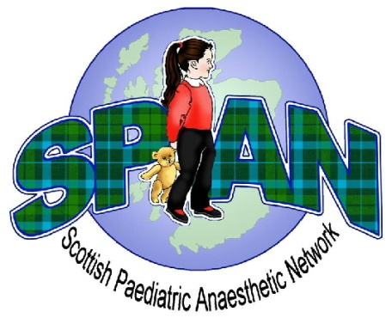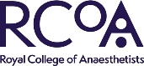 

**SPAN Webinar**

**Neonatal Surgical Emergencies, Mr James Andrews, Royal Hospital for Children, Glasgow**

**Tuesday 15th December 2020**

**Please write your name here as you would like it to appear on your CPD certificate:**

*Please evaluate today’s seminar using the criteria below and the following scale:  
 1 = Less than satisfactory, 2 = Satisfactory, 3 = Good, 4 = Very good*

|  |  |
| --- | --- |
|  |  |
| Level of detail covered: |  |
| Presenter’s delivery: |  |
| Presenter’s response to questions: |  |
| Presenter’s timekeeping: |  |
| Hand-outs and other material used *(as applicable)*: |  |
| Relevance to your personal CPD |  |

|  |  |
| --- | --- |
| Please add any comments *(as applicable)* about anything that could have made the webinar or presentation better: |  |
| Please add any other general comments here about today’s event: |  |
| Did today’s event confirm that your current knowledge is up-to-date? |  |
| What impact will today’s event have on your future practice? |  |
| What would you change if we were running this event again? |  |