Programme
08:30 – 09:00 Registration & Trade

Morning session

A) The Unstable Child (09:00-11:00)
Chair: Dr Vimty Muir
09:00 - 09:30 The collapsed Neonate Dr Neil Spenceley
09:30- 10:00 The child with multiple trauma Dr Paul Leonard
10:00- 10:30 Advances in paediatric radiology Dr Simon McGurk
10:30- 11:00 Fluid and inotropes in the sick child Dr David Rowney
11:00 – 11:30 COFFEE & TRADE

B) Anaesthesia for the child with co-morbidities (11:30-13:00)
Chair: Dr Lesley McKee
11:30- 12:00 The child with cardiac disease Dr Rob Ghent

12:00- 12:30 The child with respiratory disease/OSA Dr Suzanne Krosnar
12:30- 13:00 The child with neurological disability Dr Emma Dickson
13:00 – 14:00 LUNCH & TRADE

Afternoon Workshops: How to sessions: 14:00 – 16:15 (45 mins each)
TIVA in practice – the do’s and don’ts
Dr Alistair Baxter

Simulation – the role of local & national centres
Professor Ralph MacKinnon, Dr David Rowney & Dr Pam Winton

Management of major haemorrhage
Dr Emma Dickson, Dr Carolyn Smith & Dr Suzanne Krosnar

Close of meeting 16:15-16:30

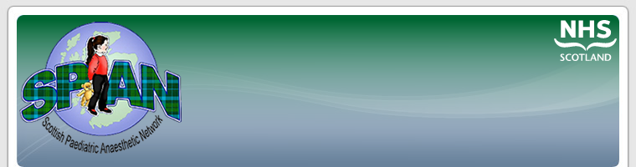

Scottish Paediatric Anaesthesia Network (SPAN)

SPAN exists to improve the care of children in Scotland, through education, support and co-operation. It aims to help professionals involved in the care of anaesthetised children, through maintaining skills, sharing experiences and offering assistance.

To find out more information please contact the current Chair:

Dr Lesley McKee at
lesley.mckee@nhs.net

Or visit us at

www.span.scot.nhs.uk

Booking Form

Name…………………………………
Hospital………………………………
Address for Correspondence
…………………………………………………………………………………………………………………………………………………………………………
Email:…………………………………
………………………………………..
Special Dietary Requirement Y/N
Detail…………………………….
Grade (Please Tick)
Consultant / SAS £100 ◻
Medical trainee £50 ◻
Nurse/ ODP £25 ◻
Please complete and return with cheque for appropriate amount
(Made payable to SPAN) to:

Dr Carolyn Smith
Dept of Anaesthetics
Royal Hospital for Sick Children
Sciennes Road
Edinburgh
EH9 1LF

carolyn.smith2@nhs.net
The Teacher Building is located in the heart of the city’s St Enoch Square fully accessible by all major transport links

By rail:
Glasgow’s St Enoch Station on the city’s subway network is approximately 20 yards from the entrance to Teacher Building and can be seen upon exit from the station (come out and turn right into St Enoch Place). For more information about subway routes and train travel, please visit Traveline Scotland’s website.

Walking:
From Glasgow Queen Street: Come out of the station onto George Street with George Square ahead of you. Turn right and take Queen Street down and turn right onto Argyle Street. Take the first left onto Buchanan Street to meet St. Enoch Square and Teacher Building.

From Glasgow Central Station: Come out of the station onto Union Street. Walk straight down and turn left onto Argyle Street. Take the first road on the right into St Enoch square, where IET Glasgow: Teacher Building is on the right.

By road:

From the North: Via the A82 and M8, exit junction 19
From the East: Via the M8, exit junction 19
From the South: Via the M74 and M8, exit junction 19
From the West: Via the M8, exit junction 19

From M8, Junction 19:

Leaving Junction 19, you come onto Argyle Street (A814). Follow this road until you reach Jamaica Street on your right. Turn into Jamaica Street and follow down until Howard Street on your left. There is a Thistle Car Park is on the corner where these 2 streets meet.

Scottish Paediatric Anaesthesia Network

Friday 29th November 2013

SPAN Biennial Educational Meeting

Teachers Building, Glasgow

£100- Consultants / SAS
£50 - Trainees
£25- Nurses/ ODP’s

