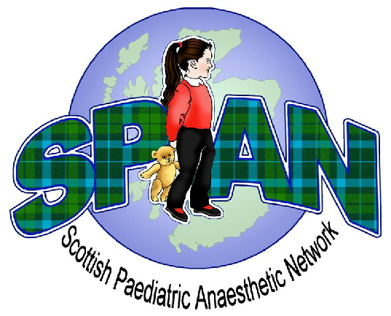
Scottish Paediatric Anaesthetic Network AGM
Friday 26th April 2013
Hilton Dunkeld House Hotel

Programme

0930 - 1000 Coffee & Registration

1000 –1030 Dr Kathy Wilkinson
Reflections on the organisation of paediatric surgical services

1030 - 1045 Questions

1045 –1115 Coffee

1115- 1145 Alistair Baxter – TIVA in children

1145-1200 Questions

1200 - 1245 Audit & Research Presentations

1245 – 1300 SPAN AGM

1300 - 1400 LUNCH

1400 – 1430 APA Peer Review – Good Practice to share
Dr Ros Lawson
Dr Chris Hawksworth – Crosshouse

National Cochlear Implant Service

1430- 1445 Questions

1445 –1530 Dr Marie Therese Hosey & Dr Grant Rodney
Guidelines for the management of children referred for dental extractions under GA

1530- 1545 Questions & close of meeting

