Emergency treatment of the convulsion

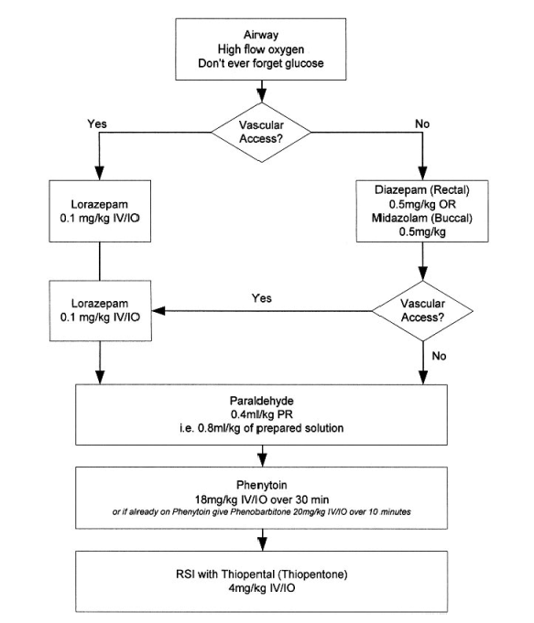
Source: APLS manual 4th edition

