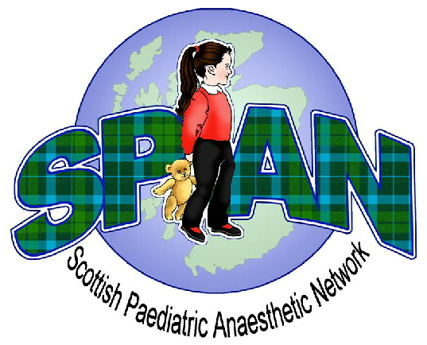
Seventh Annual Meeting
Friday 27th April 2012
Hilton Dunkeld House Hotel

Registration form
Fee: Day delegate Friday £50

Accommodation: Overnight Thursday D,B&B £120

Please book day delegate fee as detailed below
Please book accommodation directly with hotel quoting ‘SPAN 27th April 2012’ Hotel Tel: 01350 728333

Personal Details:

Name…………………………………………………………………………….

Contact Address………………………………………………………………

……………………………………………………………………………………

Hospital…………………………………………………………………………

Email.........................................................................................................

Specific Dietary requirements………………………………………………

Will you be taking dinner and accommodation offer? Y / N

Please make cheques payable to ‘SPAN’ and send with completed application form to:
Freda Forrest (SPAN)
Operating Theatres
Royal Aberdeen Children’s Hospital,
Westburn Road,
Aberdeen AB25 2ZG

CLOSING DATE: Thursday 5th April 2012

